• Insert the USBASP into your USB port

• The system will attempt to install a driver from Windows Update  
[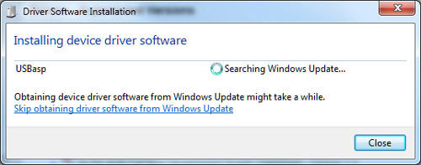](http://ba.protostack.com/2011/05/usbasp_win7_01_lrg.jpg)

• and will fail  
[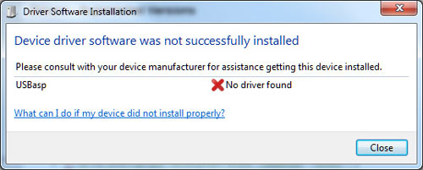](http://ba.protostack.com/2011/05/usbasp_win7_02_lrg.jpg)

• At this point, go into device manager and find the entry for the USBASP programmer. It should be displayed with a yellow alert icon next to it.

• Right click on the device and select “Update Driver Software”  
[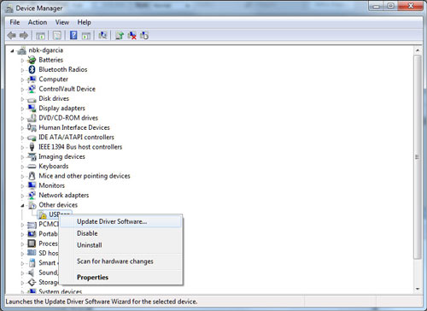](http://ba.protostack.com/2011/05/usbasp_win7_03_lrg.jpg)

• When prompted “How do you want to search for driver software”, select “Browse my computer for driver software”  
[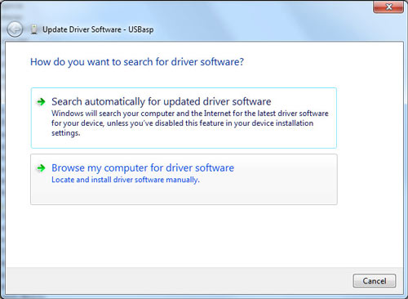](http://ba.protostack.com/2011/05/usbasp_win7_04_lrg.jpg)

• Select the folder where you unzipped the driver files then click “Next”  
[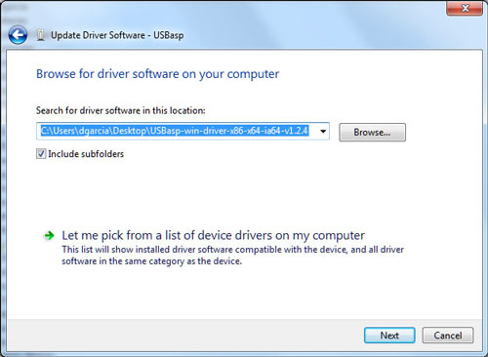](http://ba.protostack.com/2011/05/usbasp_win7_05_lrg.jpg)

• At this point, windows will give you a nice red warning dialog with the message “Windows can’t verify the publisher of this driver software”.  
[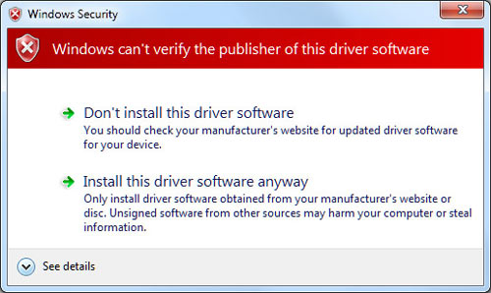](http://ba.protostack.com/2011/05/usbasp_win7_06_lrg.jpg)

• Click “Install this driver software anyway” and the driver will install.  
[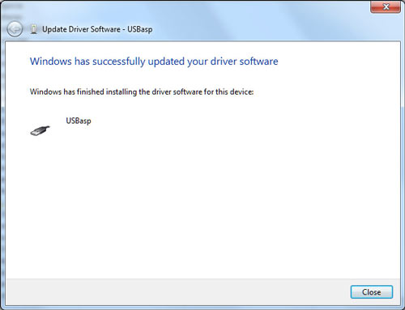](http://ba.protostack.com/2011/05/usbasp_win7_07_lrg.jpg)